Jason DeSeve
July 14, 2006

Proposed English Masking Technique:

K4 English masking technique is very straight forward. It uses a five digit binary # with a simple transposition (5 rows by 97 columns). Since the 5 digit binary has 32 possible combinations and English has 26 letters we are left with 6 additional characters. For now let us assume the letters repeat and we will use the lower case for these:

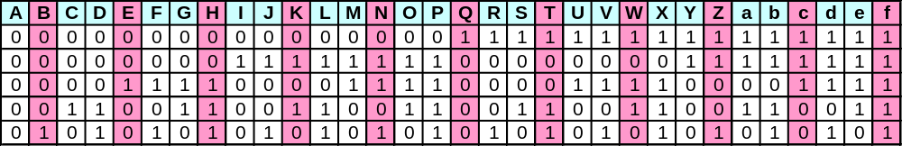

The binary # for each letter is given vertically. For example the letter O is 0 1 1 1 0. Now we replace the K4 plain text with the binary number vertically by columns and read off the original letter horizontally.

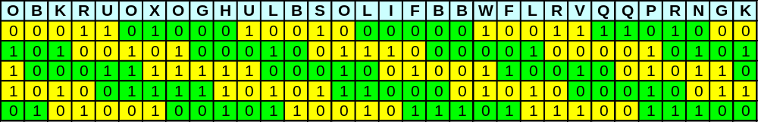

etc……….

Do you notice anything? ……Look Below ….We have our key!

E | N | D | y | a | H | r | O | H | N
0 | 0 | 0 | 1 | 1 | 0 | 1 | 0 | 0 | 0
O | B | K | R | U | O | X | O | G | H
0 | 0 | 0 | 1 | 1 | 0 | 1 | 0 | 0 | 0

I calculate the odds of the first bit of each of the first 7 letters of K 4 to match the raised letters in the first section of K3 at being 1 in 123 ( slightly less than 1/(2^7) or .62^4 * .38^3 since there are only 10 1's and 16 0's possible

If we read off left to right we get:

D | I | S | A | T | a | G | f | O | O
R | C | B | O | R | D | Q | F | I | N
F | C | O | B | B | K | I | E | H | D
S | M | c | N | R | S | K | A | R | D
f | C | J | S | L | C | Q | C | E | C
F | V | S | b | C | B | O | Y | K | P
V | Y | K | C | P | e | T | J | L | J
A | L | D | e | b | N | B | R | J | F
S | d | c | c | C | S | B | T | K | D
b | b | R | P | I | I | B

DISAT aGfOO RCBOR DQFIN
FCOBB KIEHD SMcNR SKARD
FCJSL CQCEC FVSbC BOYKP
VYKCP eTJLJ ALDeb NBRJF
SdccC SBTKD bbRPI IB

If we do frequency analysis we get: (Top as written, bottom assume lower case are same as upper case)

The distribution looks like it could be English after Maybe a simple monoalphabetic substitution and transposition.

Maybe someone with a computer program can finish it off.

